Tech Startup: Product Announcement
Focus Area: Mobile Marketing for Voice Assistants Amazon Alexa and Google Assistant
Location: VOICE Summit 2019 Newark, NJ – tech session speakers & exhibitors

Whetstone Technologies Announces SoniBridge – Enabling Mobile Marketing for Voice Assistants

July 22, 2019 – Newark, NJ, New York, NY, Philadelphia, PA, USA - Whetstone Technologies announces the general availability of the SoniBridge platform, spanning the gap between voice assistants and mobile marketing via text messaging. The company will be demonstrating their patent-pending, voice-first technology at the 2019 VOICE Summit in Newark, NJ from July 22-25.
“We developed the SoniBridge platform to close the customer engagement loop while delivering a frictionless, beneficial user experience. Our technology enables clients to increase offer redemption and lead generation rates with immediate digital fulfillment to a customer’s mobile device after interacting with a brand’s Amazon Alexa or Google Assistant voice app,” said Sanjeev Surati, CEO of Whetstone Technologies.
Examples - Whetstone Technologies clients may have voice apps using SoniBridge on both Amazon Alexa and Google Assistant that include an optional text message sent immediately to the customer for:
- An offer or coupon
- Instructions, white papers or videos
- Information on how to contribute or volunteer for a charity or political campaign.
Customers could be in the store, driving to the restaurant, attending a candidate’s rally or at home seeking instructions for product use or assembly. During the voice app interaction, they have the option to request digital items be delivered to their mobile device.
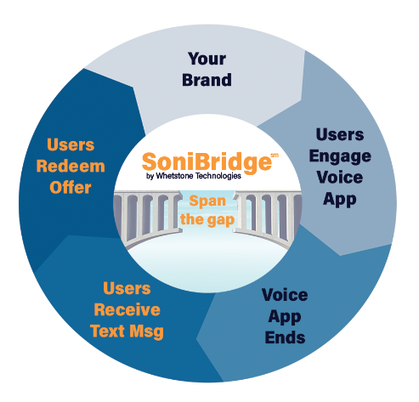

“The SoniBridge platform provides return on investment (ROI) by complementing a brand’s marketing strategy, utilizing their existing content in a new way. Our clients can offer mobile marketing voice apps without learning and managing rapidly evolving voice technology,” commented John Iwasz, CTO of Whetstone Technologies. “Multimodal, voice-first apps are highly engaging to end users.”
SoniBridge works with Amazon Alexa and Google Assistant today and can accommodate other voice assistants. The enterprise-grade platform is designed to protect customer data and expand and extend with emerging technology.
Experience the SoniBridge platform now. Ask Alexa to “open Whetstone Technologies” or tell Google to “talk to Whetstone Technologies.” Follow the interaction all the way to the end for the complete experience --- and get a free white paper from our voice technology experts.
The founders of Whetstone Technologies, Sanjeev Surati and John Iwasz, will be conducting two technical sessions at the VOICE Summit 2019. Visit them at the SoniBridge by Whetstone Technologies table in Startup Alley during the conference. See their session information at: www.whetstonetechnologies.io/voice-summit-2019 and www.voicesummit.ai .
Whetstone Technologies provides professional services to design, develop, deploy, measure and manage voice apps using their SoniBridge platform. The enterprise-grade technology spans the gap between voice assistants and mobile marketing via text messaging. Visit www.whetstonetechnologies.io and follow us on social media.

Additional resources: VOICE Summit 2019 www.voicesummit.ai
VOICE Summit 2019 tech sessions - https://www.whetstonetechnologies.io/voice-summit-2019
The State of Voice Assistants as a Marketing Channel – July 2019 – voicebot.ai
https://voicebot.ai/wp-content/uploads/2019/07/the_state_of_voice_assistants_as_a_marketing_channel_2019_voicebot.pdf

Contact:
Patricia Curry
Whetstone Technologies
610-345-7384
patricia@whetstonetechnologies.io

