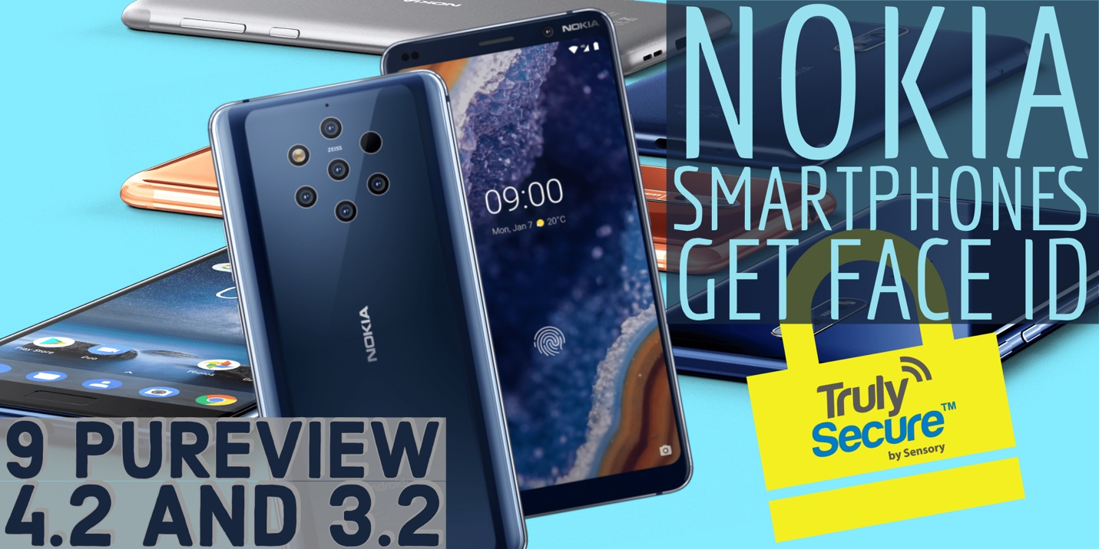

PRESS RELEASE:
For Immediate Release:

Media Contacts:

Michael A. Farino
New Era Communications Services
sensory@newerapr.com
(949) 346-1984

HMD Global Selects Sensory to Secure Nokia Smartphones with TrulySecure Face ID

TrulySecure is Sensory’s class-leading on-device facial recognition solution found in top-selling smartphones from leading brands and more than three dozen banking apps

BARCELONA and SANTA CLARA, Calif., – Feb 27, 2019 – Sensory, a leader in speech and vision technologies that enhance the user experience and security of consumer electronics, today announced HMD Global, the home of Nokia phones, has integrated TrulySecure facial recognition into three of the Nokia smartphones it has launched at MWC 2019. As deployed, TrulySecure allows Nokia 9 PureView, Nokia 4.2 and Nokia 3.2 users to unlock their phone via powerful facial recognition.

TrulySecure is a FIDO Certified™ biometric authentication technology that quickly, conveniently and securely recognizes enrolled users via powerful face biometric recognition technologies. Featuring the latest in Sensory’s embedded AI technology, TrulySecure can identify and authenticate enrolled users in less than a second and differentiate individuals at a 99.999% accuracy rate. Boasting industry-leading on-device liveness detection and anti-spoofing algorithms, TrulySecure makes it nearly impossible for an imposter to gain access to a protected device or app. Mitigating the security concerns of competing facial recognition technologies, TrulySecure runs completely on device, stores biometric profiles as highly encrypted irreversible code, and never sends biometric data over the internet.

“Data and device security are extremely important decision factors when it comes to purchasing a smartphone,” said Todd Mozer, CEO at Sensory. “We’re excited to be working with HMD Global to outfit the latest Nokia smartphones with powerful on-device facial recognition-based authentication. Our technology offers users an extremely convenient means of unlocking their devices and apps, while offering extreme protection against intruders.”

For more information about this announcement, Sensory or its technologies, please contact sales@sensory.com ; Press inquiries: press@sensory.com.
# # #

About Sensory Inc.
Sensory Inc. creates a safer and superior UX through vision and voice technologies. Sensory's technologies are widely deployed in consumer electronics applications including mobile phones, automotive, wearables, toys, IoT and various home electronics. With its TrulyHandsfree™ voice control, Sensory has set the standard for mobile handset platforms' ultra-low power "always listening" touchless control. To date, Sensory’s technologies have shipped in over a billion units of leading consumer products.

